**User Requirements:**

1- The possibility of registering patients for an account with unique identifiers (email, password) to access the system.  
  
2- A secure login process that ensures confidentiality and data security.  
  
3- The ability to update and manage personal information (name, contact details, address, nationality, date of birth) of patients.  
  
4- View the information of the booked facility and the associated dates.

5. View the appointment date and upcoming schedules.  
  
6- The ability to reserve a facility for specific medical purposes.

7- Prevent multiple facilities from being booked by the same patient at the same time.

8. Access to information about available medical equipment.

9- The ability of patients to use and reserve specific equipment.

10. Ensure that personal data is secure and cannot be accessed by unauthorized individuals.

11- Confirm data backups for reliability.

**System Requirements:**

1. Secure login system with encrypted password storage.

2. Authorization protocols for access control based on user roles (patient, doctor, staff).

3- A central database to store patient information, doctor details, nurse and staff details, facility information and equipment data.

4. Unique identifiers (IDs) for patients, doctors, facilities and equipment for efficient data retrieval.

5. Validations to ensure data integrity (e.g., unique email constraint, mandatory fields).

6. A system to handle facility bookings by patients and allocate equipment for patient use.

7. Regular and automated data backup to prevent data loss in case of system failure or data corruption.

8- Implement data encryption methods to protect sensitive patient information.

9. Monitor and record the activities of the system for the purposes of security analysis and auditing.

10- System logic to ensure that the default values ( Jordanian) are set when the necessary data is not provided.

11. Flexible network infrastructure to ensure smooth connectivity, especially during high load times.

**2 - You are asked to formulate detailed user and system requirements accurately for the MediCRE Health Cloud database system. Next, the cloud database system schema was created by creating an entity relational schema (ERD), including schematic representation of entities, their attributes, and relationships between tables.**

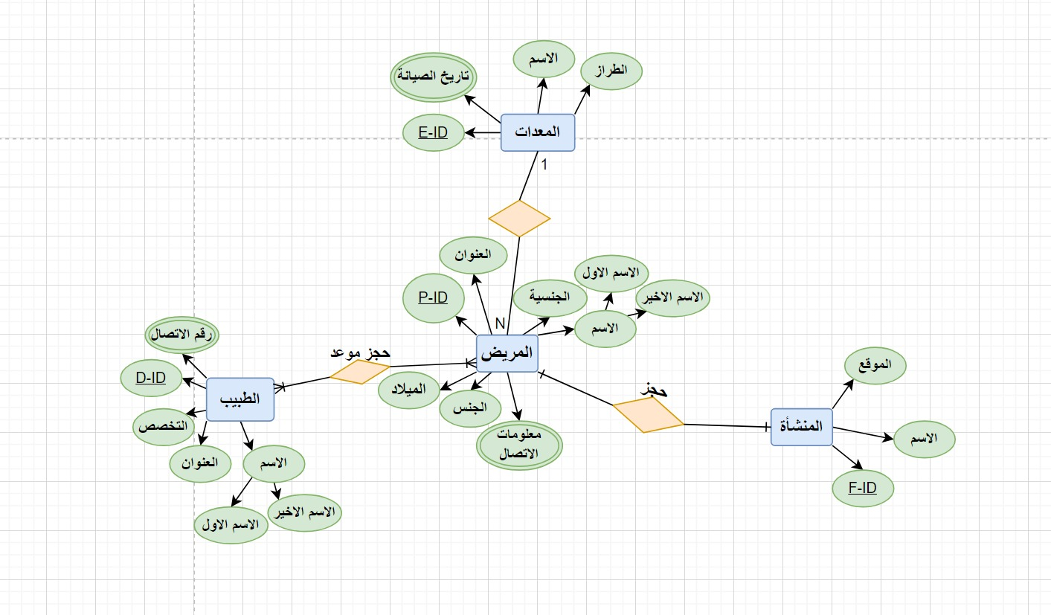

**3 - You were tasked with designing the relational cloud database, and turning it into a logical database design that includes**

**Database schema elements such as fields, data types, constraints, and specifying primary and foreign keys .**

Doctor

|  |  |  |
| --- | --- | --- |
| Restrictions | Type of data | Features |
| HP | Int | D-ID |
| NOT NULL | VARCHAR (20) | First Name |
| NOT NULL | VARCHAR (20) | Second Name |
| Not null | VARCHAR (10) | Specialization |
| Not null | VARCHAR (30) | Address |

Contact Number

|  |  |
| --- | --- |
| Data Type | Attributes |
| int | Contact Number |
| HP | D-ID |

Patient

|  |  |  |
| --- | --- | --- |
| Restrictions | Data Type | Features |
| HP | Int | P-ID |
| NOT NULL | VARCHAR (20) | First Name |
| NOT NULL | VARCHAR (20) | Second Name |
| Not null | VARCHAR (10) | Sex |
| DEFAULT 'Jordanian' | VARCHAR (20) | Nationality |
| Not null | Int | Date of birth |
| Not null | VARCHAR (30) | Address |

Contact Information

|  |  |
| --- | --- |
| Data Type | Attributes |
| VARCHAR(10) | Contact Information |
| HP | P-ID |

Equipment

|  |  |  |
| --- | --- | --- |
| Restrictions | Data Type | Features |
| HP | Int | E-ID |
| Not null | VARCHAR (10) | Name |
| Not null | VARCHAR (10) | styler |

Maintenance history

|  |  |
| --- | --- |
| Data Type | Attributes |
| VARCHAR(10) | Maintenance history |
| HP | E-ID |

Facility

|  |  |  |
| --- | --- | --- |
| Restrictions | Data Type | Features |
| HP | int | F-ID |
| Not null | VARCHAR(10) | Name |
| Not null | VARCHAR(20) | Site |

Relations

|  |  |
| --- | --- |
| مع المريض(Many-to-Many) | Doctor |
| مع الطبيب(Many-to-Many) | Patient |
| مع المعدات (Many-to- One) | Patient |
| مع المنشأة(One-to-One) | Patient |
| مع المريض(One-to-Many) | Equipment |
| مع المريض(One-to-One) | Facility |

**4 - Select the right hosting options for the MediCare Health Cloud database system, considering factors such as cloud-based platforms, cloud hosting security, cloud hosting services, and potential cloud hosting vendors.**

This is what I used for cloud instances (cloud platforms, cloud hosting security, cloud hosting services, cloud hosting vendors):

First of all, I must explain deployment models that indicate the different ways in which cloud computing resources are made available and made available to organizations and users. The basic deployment models are:

-Public cloud: In public cloud deployment, cloud services are provided by external providers over the Internet. These services are available to many organizations and users. The cloud provider is responsible for managing and maintaining the underlying infrastructure, while users use the services on a pay-as-you-go basis.

-Private cloud: The private cloud is exclusively for a single organization and is usually hosted on-premises or in a data center. It offers greater control, security, and customization options compared to public clouds. The private cloud is suitable for organizations with specific compliance requirements or a strong need for data privacy.

-Hybrid cloud: Hybrid cloud combines public and private cloud environments. It enables organizations to leverage the benefits of both deployment models by integrating their on-premises infrastructure with public cloud services. This provides flexibility, scalability, and the ability to choose the most suitable platform for different workloads.

In the context of MediCare Health Cloud, I chose hybrid cloud to deploy my cloud. This means that I use a combination of public cloud services (specifically AWS) and private cloud infrastructure. Hybrid cloud approaches provide me with the flexibility to leverage AWS's scalability and end-to-end service offerings while maintaining control over sensitive data and the potential to host specific applications or services on the private cloud.

1- Cloud platforms:

*What are cloud platforms?

- Cloud platforms are the infrastructure and online services that provide computing resources, storage, and online networking capabilities. They offer scalability, flexibility, and cost-effectiveness for application hosting and data management.

* What did you use?

- AWS

*Why did you use it?

- AWS stands out for its wide range of services, global infrastructure, advanced analytics features, and a strong focus on security. By using AWS, we can leverage a wide range of cloud services such as databases, storage, machine learning, and networking. This allows the nitrogen cloud database system to be hosted and managed effectively and securely. AWS's robust security protocols, compliance certifications, and reliable infrastructure make it the perfect choice for optimal system performance, scalability, and data protection.

2- Cloud hosting security:

*What is cloud hosting security?

- Cloud hosting security refers to the measures and protocols applied to protect data and applications hosted on cloud platforms, ensure protection against unauthorized access, data breaches, and maintain the confidentiality, integrity and availability of resources.

*What did you use?

- AWS

*Why did you use it?

AWS provides a wide range of advanced security functions and offerings, including encryption, identity management, access, network security, and threat detection. With its stringent security measures, certifications of compliance, and continuous monitoring capabilities, AWS creates a robust security framework that ensures the integrity and protection of the Nitrogen Cloud database system.  
  
3- Cloud hosting services:

*What are cloud hosting services?

- Cloud hosting services refer to offers from cloud service providers that allow organizations to host their applications, data, and services in cloud infrastructure. These services include a range of functions, including compute resources, storage, networking, and more.

There are three basic service models IaaS , PaaS, andSaaS:

IaaS (Infrastructure as a Service):

IaaS is a cloud computing service model that provides virtual computing resources over the Internet. It provides infrastructure components such as virtual machines, storage, and networking, allowing organizations to build and manage their software applications and environments without the need for physical hardware.

PaaS (Platform as a Service):

PaaS is a cloud computing service model that provides a platform for developing, deploying, and managing applications. It provides a complete development and operating environment, including infrastructure, development tools and services. PaaS allows organizations to focus on application development without worrying about managing critical infrastructure.

SaaS (Software as a Service):

SaaS is a cloud computing service model where software applications are provided online on a subscription basis. With SaaS, organizations can access and use software applications without the need for installation or maintenance, as all management and updates are handled by the service provider.

* What did you use?

To meet the needs of MediCare Health Cloud, I chose IaaS, specifically using AWS (Amazon Web Services), due to its wide range of services, global infrastructure, and robust security protocols.

*Why did you use it?

- AWS offers a wide range of cloud services, including databases, storage, machine learning, and networking, enabling efficient and secure hosting and management of the Nitrogen Cloud database system. With AWS's reliable infrastructure and security features, we can ensure optimal system performance, scalability, and data protection, and AWS provides a flexible, adaptable, and convenient cloud hosting environment for the Nitrogen Cloud database system.

4- Cloud hosting vendors:

*What are cloud hosting vendors?

Cloud hosting vendors are companies that provide enterprise cloud computing infrastructure and services, allowing them to host their applications, data, and services in the cloud.

* What did you use?

- AWS

*Why did you use it?

- AWS offers a comprehensive suite of cloud hosting services, including virtual machines, storage, databases, and networking. It features a dependable and scalable infrastructure, advanced analytical capabilities, and robust security features. Leveraging AWS's expanded global network, comprehensive suite of services, and competitive pricing, it provides a flexible and adaptable hosting solution that is ideal for the Nitrogen Cloud database system.

**5 - Build an all-in-one design featuring easy-to-use input and output interfaces, using tools like wireframes, Figma, or other interface design tools.**  
1- Homepage:  
  
Design feature: Homepage design takes full advantage of cloud resources. It incorporates dynamic content delivery, ensuring that users have access to personal, up-to-date information. In addition, caching is implemented effectively, reducing server overhead and improving overall performance.  
 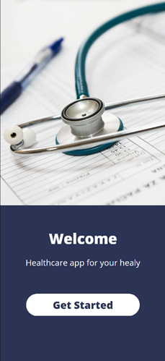

2- Login page:  
  
 Design feature: Login page design leverages cloud hosting capabilities by implementing secure authentication mechanisms. It uses encryption protocols and secure communication channels, enhancing the overall reliability and security of the login process.  
  
3- Registration page:  
Design feature: Registration page design leverages cloud resources by implementing load balancing. This ensures that registration requests are distributed evenly across multiple servers, preventing bottlenecks and providing a seamless registration experience for users.  
  
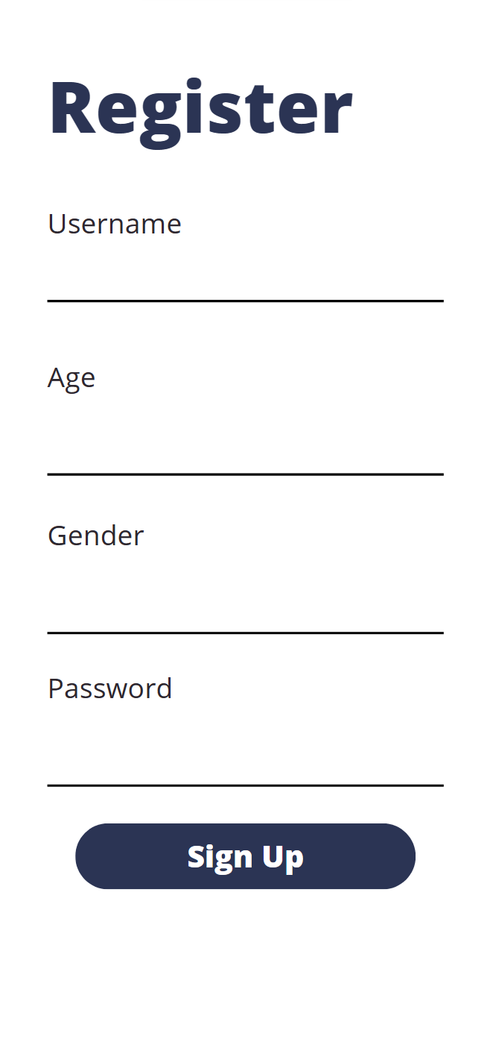  
4- Services page:  
 Design feature: Notification page design leverages cloud hosting capabilities by integrating with the design feature: Services page design takes advantage of cloud hosting capabilities by integrating real-time updates and delivering dynamic content. Users can easily view doctors' availability, receive live updates on booking schedules, and schedule appointments without experiencing delays or server overloads.  
  
5- Notification page:  
Design feature: Notification page design takes advantage of cloud hosting capabilities by integrating with push notification services. Users receive instant notifications about appointment time, equipment availability, and progress tracking, enhancing their overall engagement and experience with the app or website.  
  
  
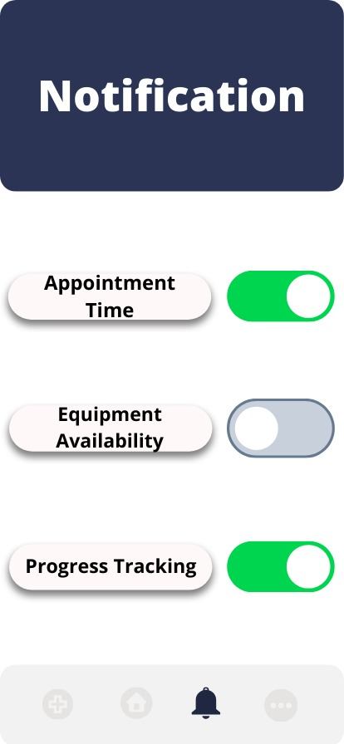  
  
  
**6. Finally, measurement and reflection where an assessment is required of the extent to which the submitted design components, including the ARD, logical design diagram and interface design, represent the requirements of the user and the specific system.**

|  |  |  |
| --- | --- | --- |
| Requirements | Applied? | Directory |
| 1- The possibility of registering patients for an account with unique identifiers (email, password) to access the system. | Yes | Focus on data security in the cloud-based hospital database system on the registration page. |
| 2- A secure login process that ensures confidentiality and data security. | Yes | Secure login system with encrypted password storage. Delegation protocols to control access based on user roles on the sign-in page. |
| 3- The ability to update and manage personal information (name, contact details, address, nationality, date of birth) of patients. | Yes | Having unique patient identifiers such as patient ID, name, contact details, gender, date of birth, address, and nationality on the registration page. |
| 4- View the information of the booked facility and the associated dates. | Yes | Patients can book one facility, share equipment among multiple patients, and allow each patient to use only a specific equipment on the services page. |
| 5. View the appointment date and upcoming schedules. | Yes | Include the doctor selection feature in the appointment booking interface to know important information. |
| 6- The ability to reserve a facility for specific medical purposes. | Yes | Patients can book one facility, share equipment among multiple patients, and allow each patient to use only a specific equipment on the services page. |
| 7- Prevent multiple facilities from being booked by the same patient at the same time. | Yes | Patients can book one facility, share equipment among multiple patients, and allow each patient to use only a specific equipment on the services page. |
| 8. Access to information about available medical equipment. | Yes | The presence of information about the equipment such as device ID, name, model and maintenance history in the database. |
| 9- The ability of patients to use and reserve specific equipment. | Yes | Patients can book one facility, share equipment among multiple patients, and allow each patient to use only a specific equipment on the services page. |
| 10. Ensure that personal data is secure and cannot be accessed by unauthorized individuals. | Yes | Secure login system with encrypted password storage. Delegation protocols to control access based on user roles. |
| 11- Confirm data backups for reliability. | Yes | Implement regular backup procedures to maintain data integrity and restore with AWS |
| 1. Secure login system with encrypted password storage. | Yes | Secure login system with encrypted password storage. Delegation protocols to control access based on user roles through AWS. |
| 2. Authorization protocols for access control based on user roles (patient, doctor, staff). | Yes | Secure login system with encrypted password storage. Delegation protocols to control access based on user roles. |
| 4. Unique identifiers (IDs) for patients, doctors, facilities and equipment for efficient data retrieval. | Yes | Unique identifiers for all attributes in the entities and the ERD schema. |
| 5. Validations to ensure data integrity (e.g., unique email constraint, mandatory fields). | Yes | Secure login system with password storage encrypted through AWS. |
| 6. A system to handle facility bookings by patients and allocate equipment for patient use. | Yes | Patients can book a single facility, share equipment among multiple patients, and allow each patient to use only a specific equipment from the services page. |
| 7. Regular and automated data backup to prevent data loss in case of system failure or data corruption. | Yes | Implement regular backup procedures to maintain data integrity and restore with AWS |
| 8- Implement data encryption methods to protect sensitive patient information. | Yes | Focus on data security in a cloud-based hospital database system with AWS |
| 9. Monitor and record the activities of the system for the purposes of security analysis and auditing. | Yes | Ensure robust network connectivity infrastructure to seamlessly handle day-to-day hospital operations with AWS |
| 10- System logic to ensure that the default values ( Jordanian) are set when the necessary data is not provided. | Yes | Ensure robust network connectivity infrastructure to seamlessly handle day-to-day hospital operations with AWS |
| 11. Flexible network infrastructure to ensure smooth connectivity, especially during high load times. | Yes | Ensure robust network connectivity infrastructure to seamlessly handle day-to-day hospital operations with AWS |

Reviewer:

1 Cook, B. (2018). Formal reasoning about the security of amazon web services. Computer Aided Verification, 38-47.

2 Park, S., Lee, Y., & Park, W. (2022). Configuration method of aws security architecture that is applicable to the cloud lifecycle for sustainable social network. Security and Communication Networks, 2022, 1-12.

3 Palade, A., Kazmi, A., & Clarke, S. (2019). An evaluation of open source serverless computing frameworks support at the edge. 2019 IEEE World Congress on Services (SERVICES).

4 Lee, K., Murray, D., Hughes, D., & Joosen, W. (2010). Extending sensor networks into the cloud using amazon web services. 2010 IEEE International Conference on Networked Embedded Systems for Enterprise Applications.

5 Byrne, R. and Jacobs, D. (2020). Development of a high throughput cloud-based data pipeline for 21 cm cosmology.

6 Bao, S., Damon, S., Landman, B. A., & Gokhale, A. (2016). Performance management of high performance computing for medical image processing in amazon web services. SPIE Proceedings.

7 Singh, V. K. and Dutta, K. (2015). Dynamic price prediction for amazon spot instances. 2015 48th Hawaii International Conference on System Sciences.

8 Alhosani, K. and Hosameldeen, O. (2023). Comprehensive study of the cloud computing service providers.

9 Lee, K., Murray, D., Hughes, D., & Joosen, W. (2010). Extending sensor networks into the cloud using amazon web services. 2010 IEEE International Conference on Networked Embedded Systems for Enterprise Applications.

10 Nazir, S., Poorun, Y., & Kaleem, M. (2021). Person detection with deep learning and iot for smart home security on amazon cloud. 2021 International Conference on Electrical, Computer, Communications and Mechatronics Engineering (ICECCME).